

Foundations of Programming

Assignment No.: 21
PROBLEM STATEMENT: Write a C program to copy contents of one file to another using file handling.

OBJECTIVE:

- To understand the concept of file handling in the C programming language.
- To learn how to read data from a file and write data into another file.
- To implement file copy operation using standard file handling functions.

THEORY:
File handling in the C programming language allows programs to store and retrieve data from files. Files are handled using file pointers and standard functions such as fopen(), fclose(), fgetc(), and fputc().

In this program, the source file is opened in read mode, and the destination file is opened in write mode. The program reads characters from the source file one by one using fgetc() and writes them to the destination file using fputc(). This process continues until the end of the file (EOF) is reached. Thus, the contents of the source file are successfully copied into the destination file.
PLATFORM: Linux

INPUT: A source file containing text data.

OUTPUT: Contents of the source file copied into another file.

CODE:
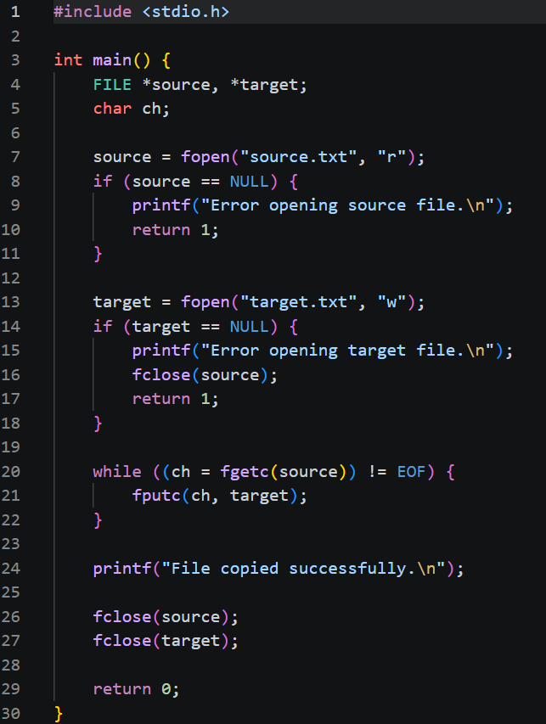

SAMPLE INPUT:
source.txt
Hello
Welcome to C Programming
SAMPLE OUTPUT:
File copied successfully.
Destination file destination.txt will contain:
Hello
Welcome to C Programming

CONCLUSION: Thus, the C program successfully demonstrates file handling operations by copying the contents of one file into another using file handling functions.

FAQs:
- What is file handling in C programming, and why is it important?
Soln: File handling in C programming refers to the process of creating, opening, reading, writing, and closing files using functions provided in the standard library (stdio.h). It allows programs to store data permanently on storage devices instead of losing it when the program ends. File handling is important because it helps in managing large amounts of data, enables data sharing between programs, and ensures data persistence for future use.
- What is the purpose of fopen() and fclose() functions in file operations?
Soln: The fopen() function is used to open a file in a specified mode (such as read, write, or append) and returns a file pointer to access the file. The fclose() function is used to close an opened file, ensuring that all data is properly saved and system resources are released.
- How does the program detect the end of a file using EOF?
Soln: The program detects the end of a file using the special value EOF (End Of File), which is returned by functions like fgetc() when no more data is available to read. During file reading, each character is checked, and when the function returns EOF, it signals that the end of the file has been reached, so the loop stops.

